LAZER AND KIMBER MEET WSGP
MSU PATHOLOGIST, DR. JON PATTERSON
By Judy Huston

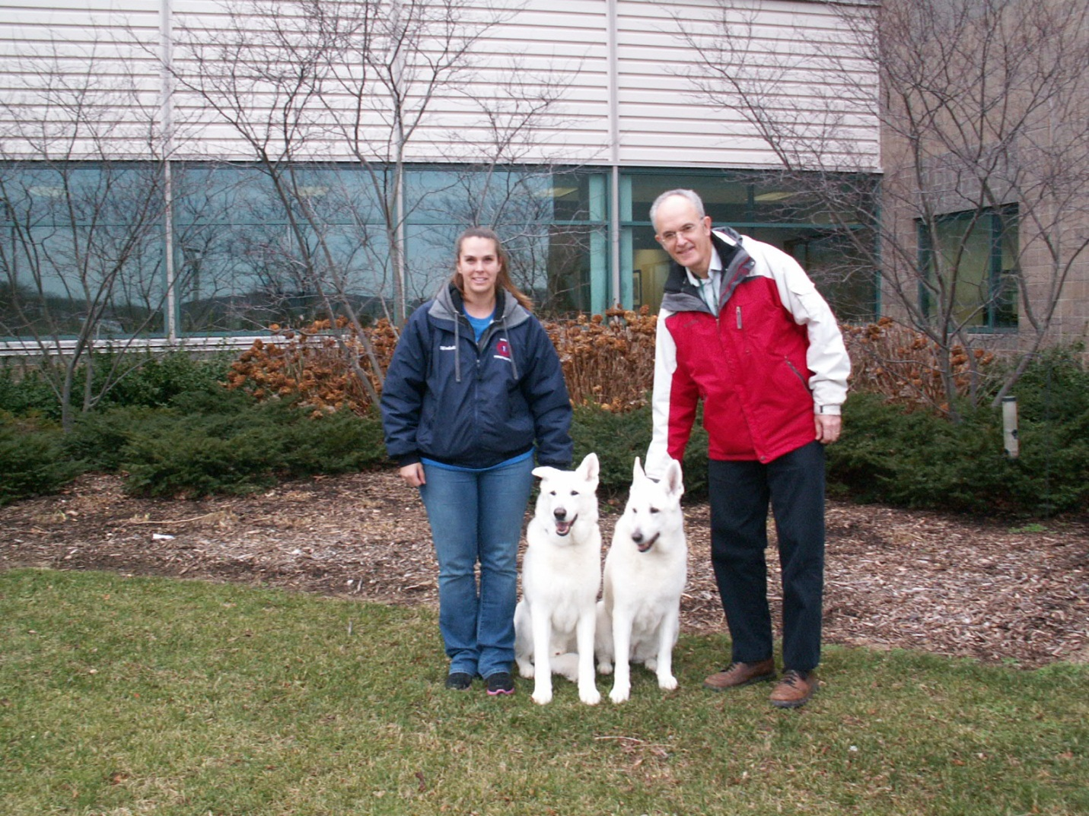
Pam and Michelle Koons bred their beloved Ashlee (Hoofprint Emerald) for the second time in 1995. One of those nine pups was my Kyra, the inspiration for founding the White Shepherd Genetics Project (WSGP). Michelle’s Luger, from Ashlee’s first litter was the dog that inspired me to fulfill my personal dream of a “white” GSD (back before I knew anything about breed separation or now, recognition). Luger was the 1st white GSD Total Dog in 1997 and I adored him. He was the first performance dog I’d ever seen in our breed and Kyra tried to follow in his paw prints.
Luger’s offspring from the only litter he sired include Luger’s Lazer Beam v Stellar, “Lazer,” and Stellar’s My White Desire, “Kimber,” and Stellar’s Lunar Eclipse, “Luna” owned by Becky Joyce.
From this family of dogs, Jaz (Pam Anderson), Kyra (Judy Huston), Chance (Linda May), Emma (Joe Jasinski), and Luger (Michelle Koons) all had a necropsy at Michigan State University. Pam and Michelle have been extended family since the day we brought Kyra home. They have volunteered every bit of health and genetic information they knew about their dogs. Michelle has already stated that she would like both Lazer and Kimber to have a necropsy when the time comes. Only time will show us the benefits the breed will experience as a result of the necropsy project, but there wouldn’t be one if people like Michelle and Pam and the owners of the 51 dogs already in the project hadn’t been willing to have their dogs participate.
In late December, 2011, Michelle and I were having a conversation about her dogs and how they were doing. Lazer and Kimber turned 13 on the 3rd of June. We talked about the possible plans for necropsy for both of them. I shared with Michelle that I was so happy, and relieved, that Dr. Jon Patterson either performs all of our White Shepherd necropsies or has left instructions with the staff about how to handle any that come in when he is away in order to be sure we get a consistent and thorough result. We recalled that Dr. Patterson did the necropsy for Luger. Michelle wondered if Dr. Patterson had ever seen a “living” White Shepherd and if, not, she had the idea that we could take Lazer and Kimber to meet him. I was especially excited about this idea because both of these dogs are in beautiful condition and both of them are ambassadors for our breed. Dr. Patterson loved the idea!
On a beautiful day in January, my six year old male, King Kole , who was sired by Polo who also had a necropsy for our program, drove over to Michigan State University to meet Michelle, Lazer, and Kimber at the Diagnostic Center for Population and Animal Health. This is where Dr. Patterson has his office and is the location where paperwork is handled before a dog is admitted for necropsy.
We arranged to meet outdoors in front of the DCPAH to get a few pictures. Dr. Patterson was very impressed with our dogs. He asked Michelle if he could use these pictures in one of his lectures since he teaches when he isn’t scheduled on the necropsy floor. His expertise is the spine.
It was a very warm and friendly meeting and both Michelle and I left feeling even more confident that our dogs were in the best of hands and treated with the utmost respect they deserve.
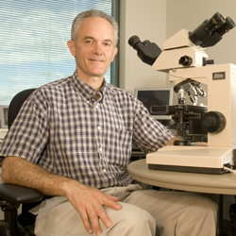
Jon Patterson, DVM, PhD, Dipl ACVP
Professor
163 Diagnostic Center for Population and Animal Health
4125 Beaumont Road
Lansing MI 48910-8107

